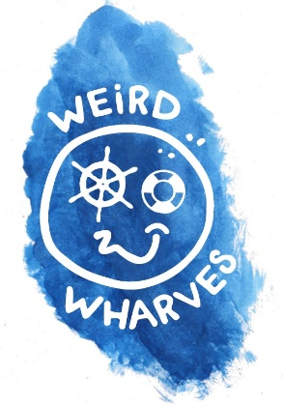
Teacher Resource Pack

How to Deliver a Weird Wharves education programme of hands-on learning experiences for Years 3 & 4.

Videos, lesson plans, images, equipment lists, logos, photos, maps, timelines and contacts to download at
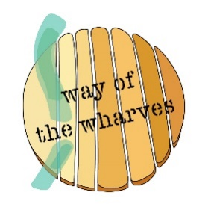
www.thewharves.org

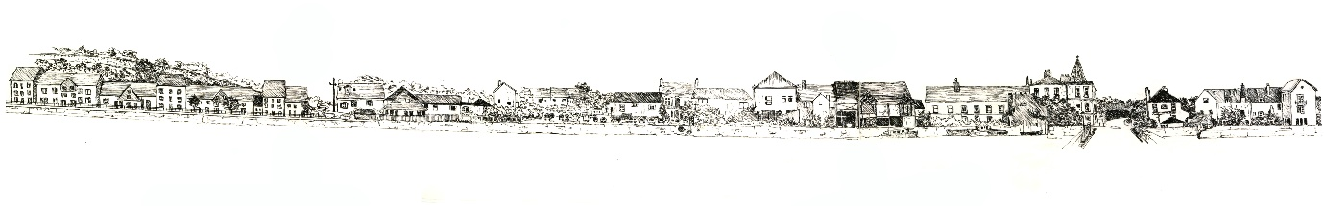

CONTENTS
Introduction 3
What is Weird Wharves 5
Tried & Tested Programme 6
Where the Wharves Are (reference map) 7
Sculpting the Wharves 8
Wharf Storytelling 9
Critter Detectives 10
Slime Kilns 11
Salt Cod Cooking & Tasting 12
Introduction to SS Freshspring 13
Tour of SS Freshspring (site visit) 14
Tie-in Lessons & Creative Ideas 15
Branding, Logos & Wharf Pen-drawings 16
Old Wharf Maps, Photos & Aerial Images 18
Lesson Plans 19
SS Freshspring Visit Risk Assessment 27
Contact Details 29

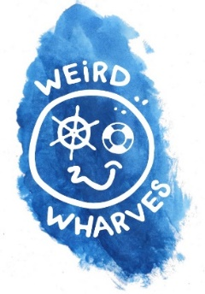

Thank you!

Thanks for downloading our Weird Wharves pack for teachers of Primary School children. Our volunteers and workshop leaders have worked hard to create this programme of learning experiences.

We know you are very busy, so have kept everything in this pack straightforward and easy to read. There are lesson plans, lots of practical ideas, images, maps and photos you can use in-class here.

On our website, there are hundreds more old maps and photos, videos, timelines and worksheets you are free to download in order to support this programme. Please do create your own lessons with these resources, but know that a lot of this programme is “ready-made” for you to call up people who can deliver tried and tested classes for you.

We hope you’ll find everything you need to deliver these learning activities. If, however, you have some questions – or can’t get hold of the person who delivers one part of the programme – then please contact me at project@bbcdevon.org

Have fun running the Weird Wharves programme, and we hope your class of children is inspired by maritime stories, events, people, wildlife and worldwide connections to Bideford, and they learn a lot of new estuary-related facts through these hands-on learning experiences.

Best wishes,
Anthony Burt
Way of the Wharves Project Co-ordinator
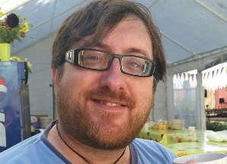

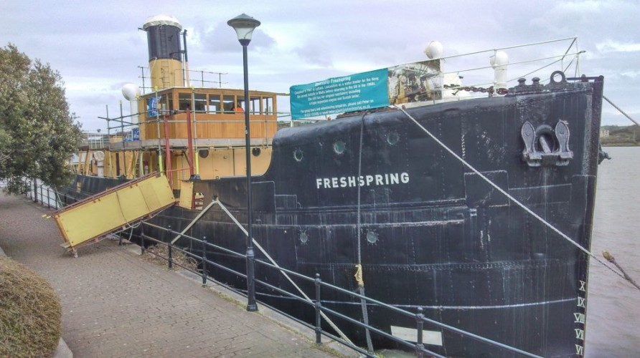
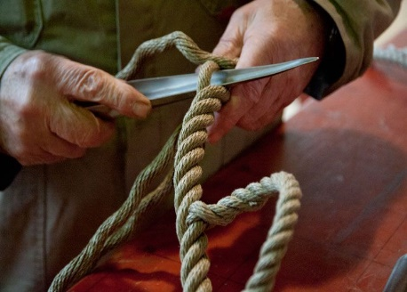
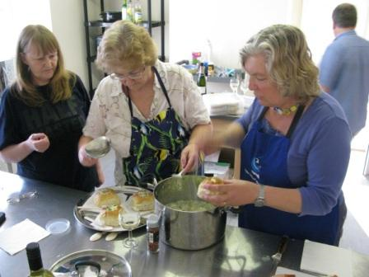
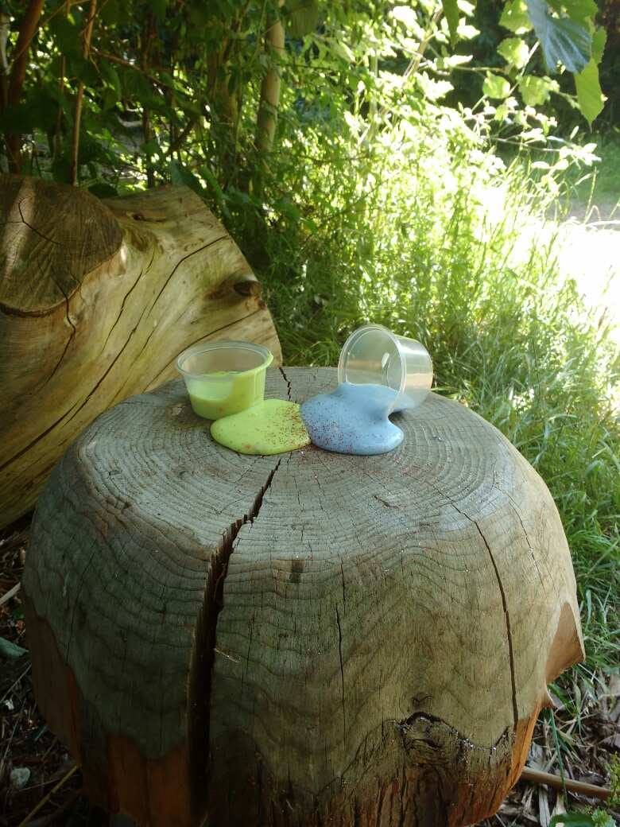
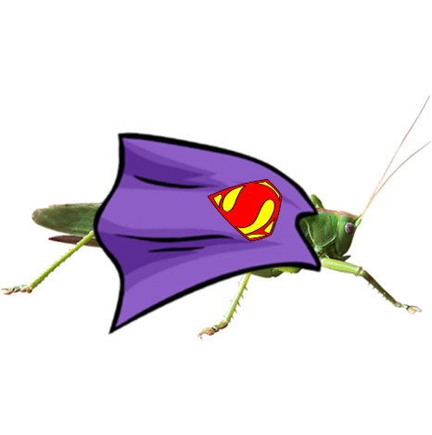
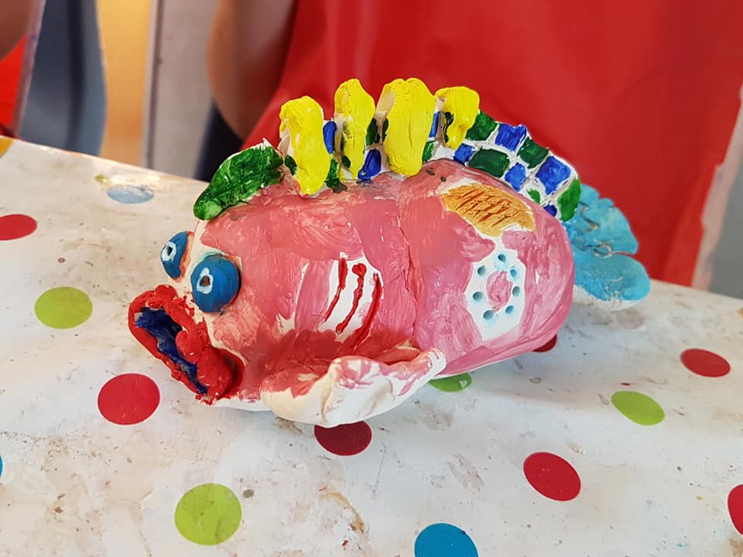
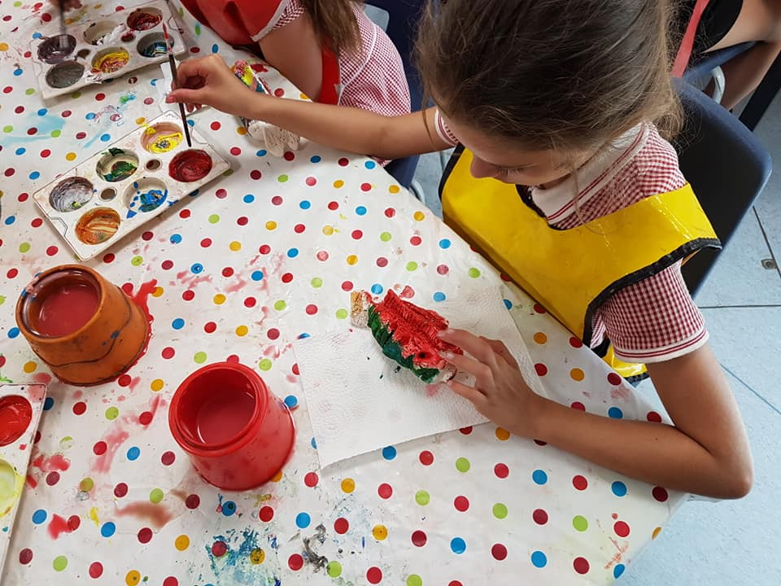
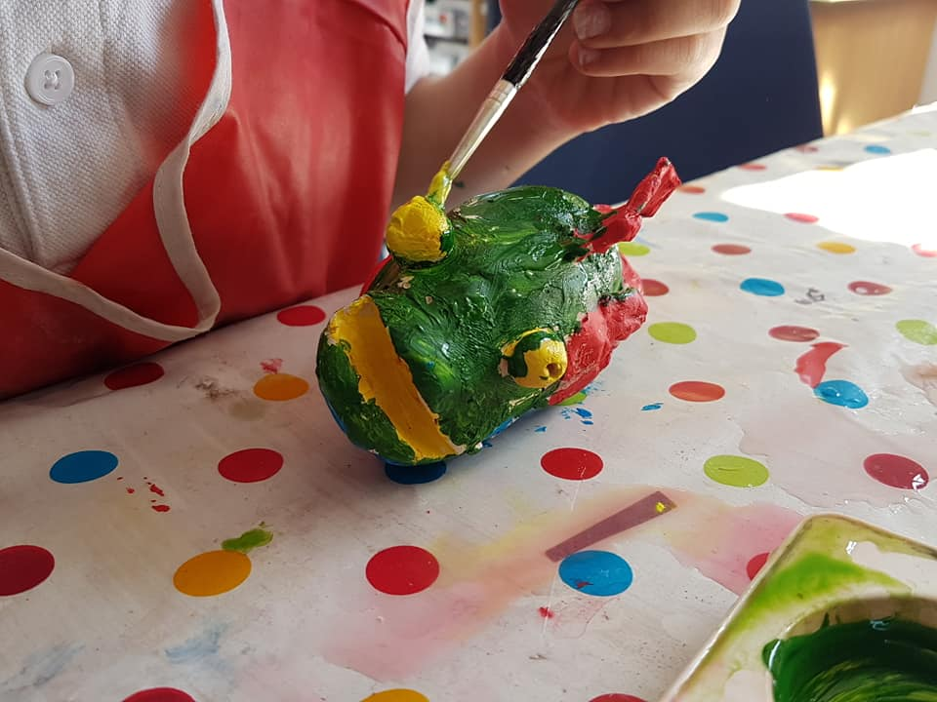
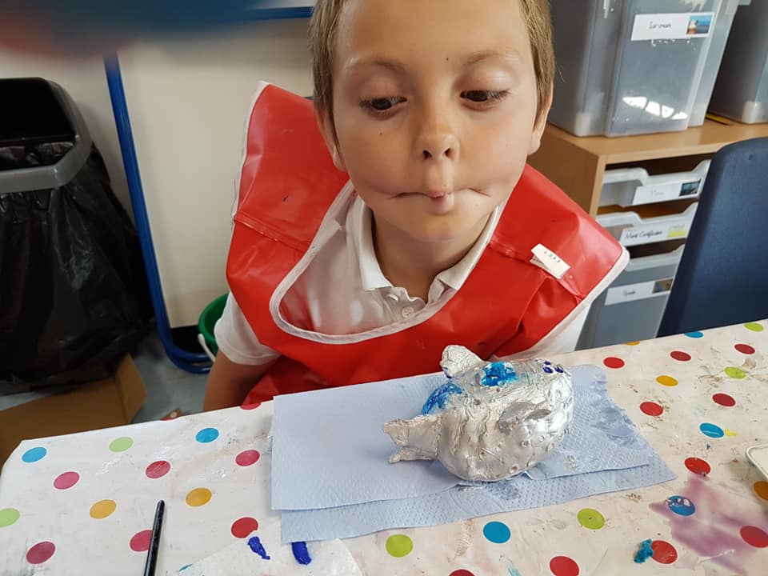
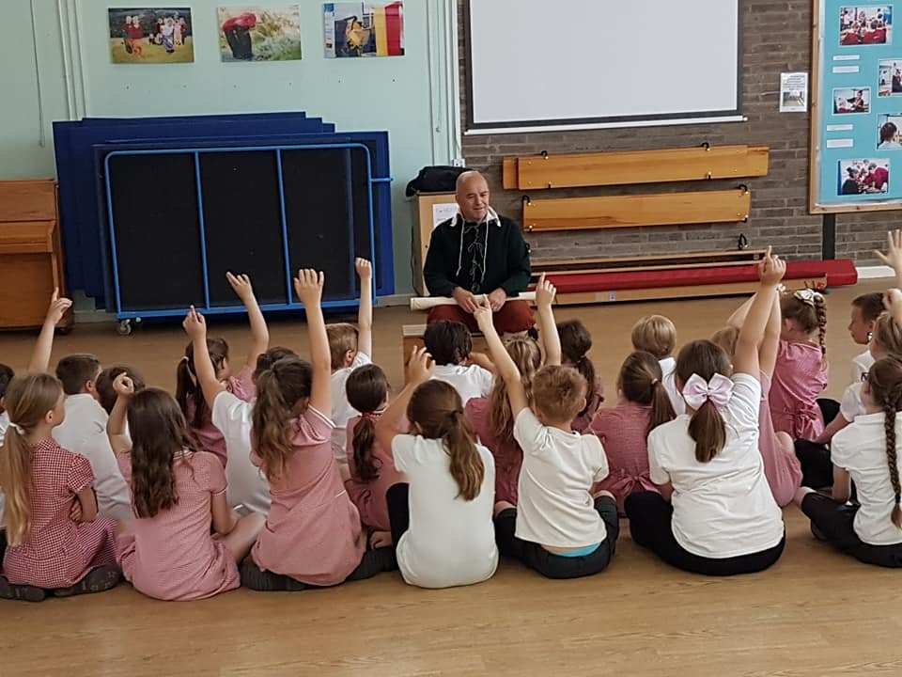
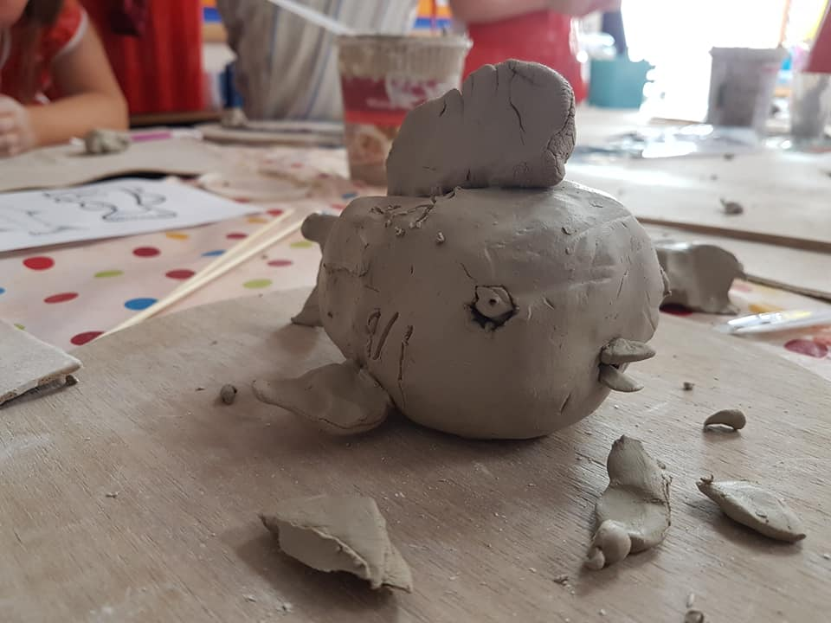
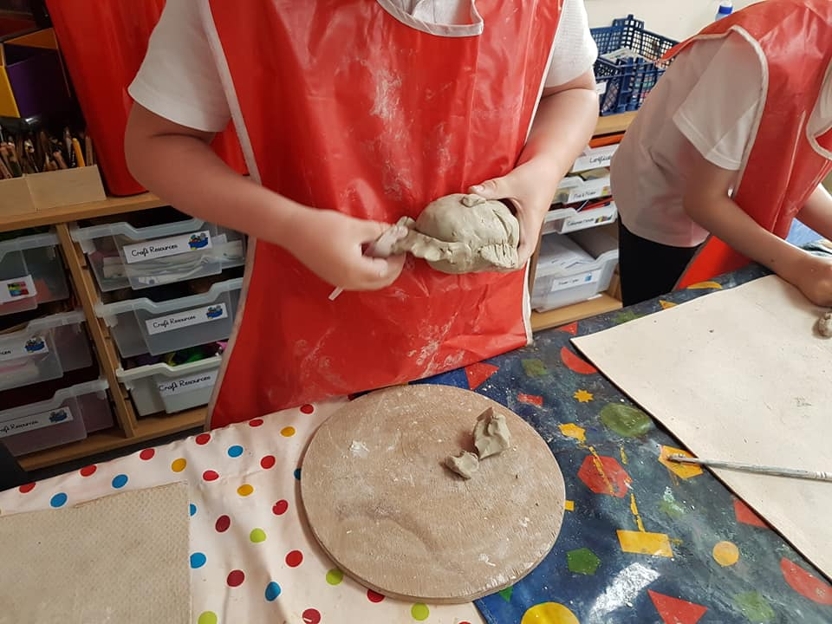
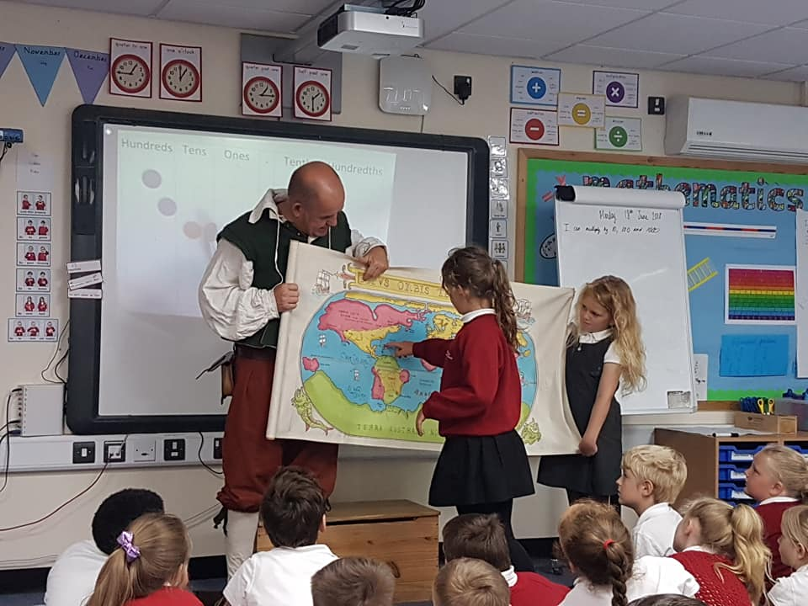

What is Weird Wharves?

It’s part of the “Living History” strand of the Way of the Wharves community project. We’re running exciting workshops and educational experiences for Years 3 & 4 under our “Weird Wharves” name.

These fun sessions (for classes of 30) are about the cultural importance and historical relevance of Bideford’s estuary, and we have been given funding by the Heritage Lottery, Bideford Town Council and Bideford Bay Creatives to create in-school community activities that are enjoyable, educational and locally-relevant.

What is Way of the Wharves?

It is a Heritage Lottery Funded community art, maritime history and engagement project focusing on re-generating pride, knowledge and involvement in Bideford’s quayside, most notably East-the-Water.

The project focuses on the heritage of Bideford’s port, how it impacted the community and wider world, and what key people were involved in shaping it. Our volunteers ensure that its secrets are uncovered and kept in an enduring legacy for future generations via workshops, events, an education programme, a website and oral history recordings.

The strands of the project are:

- produce a Heritage Trail guide for the Wharves area
- do guided walks, talks and workshops around the Wharves
- organise community events,
- research the history of the Wharves
- collect and record oral histories of people's lives and connections to the port
- deliver a new website to hold research and share findings
- train a team of volunteers
- create an on-site, quayside interpretation/info panel for people
- create a reference resource for Bideford Library

East-the-Water School – Programme “Tried and Tested”

During the summer term of 2018, the East-the-Water Primary School hosted and ran the Weird Wharves programme for 120 children of Years 3/4, which both the teachers and children enjoyed immensely.

The Head Teacher Catherine Higley said: “The children were so excited to be a part of this, they loved all the workshops!”

The Curriculum Manager, Vikki Moore, said: “The children have absolutely loved this overwhelmingly positive group of activities focusing on local topics!”

The Education Programme

Below is a list of the education programme’s activities; they’re designed to be a fun “learning as you’re doing” experience. All the people involved can deliver something similar for your school (or you could employ experts closer to you), or you can make up your own Weird Wharves classes using our website resources!

- Sculpting the Wharves – with Taz Pollard
- Wharf Storytelling – with Steve Manning
- Critter Detectives – Sciencedipity with Ruth Maclaren
- Slime Kilns – Sciencedipity with Ruth Maclaren
- Salt Cod Cooking – Brilliant Fish with Felicity Sylvester & Mike Teare
- Introduction to the SS Freshspring with Hayley Buscombe
- SS Freshspring Tour & Rope-making Workshops with Hayley Buscombe & John Puddy

The following pages give you further info, a map of where the wharves are, and resources for each lesson.
WEIRD WHARVES
WHERE THE WHARVES ARE
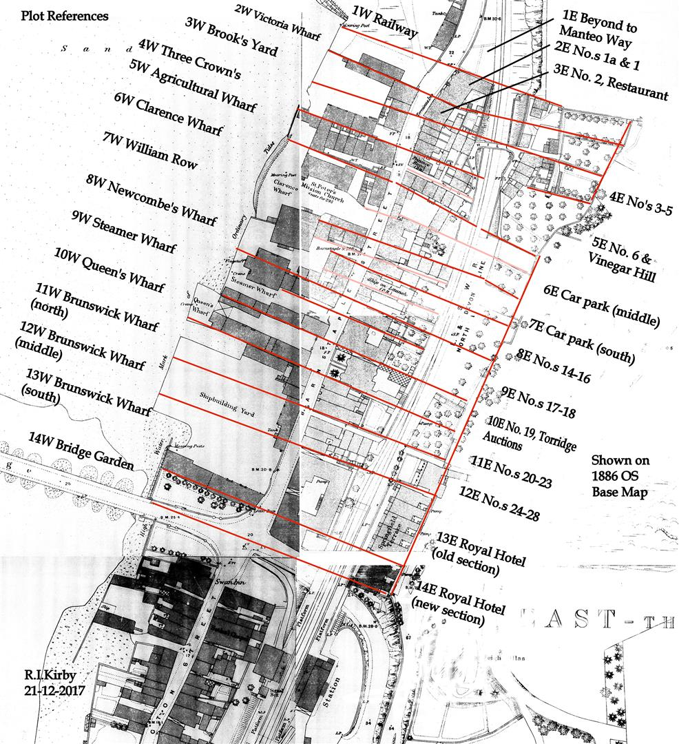

Sculpting the Wharves – Taz Pollard
Clay and Ceramic Creations – well-known and successful local ceramic artist Taz Pollard runs two days of engaging workshops, where children will learn about clay from the estuary and make their own period pot, cup or wharf wildlife sculpture. These will be fired in a kiln and then brought into school on the second day for children to paint and keep.

Structure
1-hour session for 30 children
(run over two days, a week apart for kiln firing/painting)

Learning Objectives/Outcomes
- To know where clay comes from/its links to rivers and estuaries
- To make a pinch pot fish or bird
- To refine their animals with mark making techniques

Lesson Content
- Discuss: what clay is and where it comes from. Links to rivers and estuaries
- Demonstrate: pinch pot technique.
- Practical: Pupils to make pinch pots
- Demonstrate: constructing animal from 2 pinch pots, mark making
- Practical: Pupils to construct their weird wharves animals

Assessment
Fine motor skills, pinching, squeezing, pressing and mark making

Resources Required/Supplied
Clay, slip, mark making tools, boxes for each class clearly labelled

Lesson Plans
In the pack’s appendix or to download/print at www.thewharves.org

Contact Details
Taz Pollard - tazpollardceramics@yahoo.com
www.tazpollardceramics.com
North Devon Ceramics Academy www.ndcaas.com / @taz_pollard

Wharf Storytelling – Steve Manning
Steve performs a fun mixture of four defining wharf stories – and people related to them – chosen by the WOTW volunteers. The stories to be told are “The Cows and the Crane”, “The Prisoner of Torridge House”, “The Strange Wharf”, and “The Hotel with its Own Cells”. Steve uses props, role-play and dressing up to make this an interactive experience.

Structure
1-hour session for 30 children
(run over two days, a week apart for different stories)

Learning Objectives/Outcomes
- To understand that Bideford was an important trade centre
- To learn about a local character from the past
- To enhance listening skills by listening to a story
- To interpret the story through freeze-frame drama

Lesson Content
- Introduction to Bideford, 17th century trade and John Strange
- Listen to a story about John Strange based on his portrait in Bideford Town Hall
- Interpret John’s story through freeze-frame drama

Assessment
Listening skills, group working and recall

Resources Required/Supplied
Researched stories, props, large map, costume.

Lesson Plans
In the pack’s appendix or to download/print at www.thewharves.org

Contact Details

Steve Manning - stevemanningstories@gmail.com

07932 002274

www.stevemanningstorytelling.co.uk

Critter Detectives – Sciencedipity / Ruth Maclaren
Children learn about the tiny critters and bacteria that live in the estuary and how they impact the wildlife. There will be experiments, critter detective work, microscope-looking and drawing of what they see to learn about the estuary’s microbiology.

Structure
1-hour session for 30 children

Learning Objectives/Outcomes
- Find out about microscopic organisms in the water.
- Learn the importance of microscopic life on Earth.

Lesson Content
- Hunt for and observe microscopic organisms using magnifiers and microscopes. Comment on physical features.
- Identify adaptations in these animals which enable it to survive. Comment/suggest functions of features.
- Microbes are not all “germs”. Make a superhero microbe activity – adapt your microbes to have a “good” super-power.

Assessment
Adaptations seen in pupils “good” microbe, pupil explains adaptation.

Resources Required/Supplied
Microscope, whiteboard, pond/estuary water.

Lesson Plans
In the pack’s appendix or to download/print at www.thewharves.org

Contact Details
Ruth Maclaren – sciencedipity@outlook.com
www.sciencedipity.com
Facebook - @sciencedipitydevon

Slime Kilns – Sciencedipity / Ruth Maclaren
Sciencedipity demonstrates the chemical reactions involved with creating quicklime in days gone by. Children will be shown how different chemicals react and they can do their own experiments. They will draw lime kilns, learn about their use and make further chemical reactions to create seaweed slime.

Structure
1-hour session for 30 children

Learning Objectives/Outcomes
- Know what a Lime Kiln is and what happens in one.
- Give examples of what happens in a chemical reaction.
- Be able to carry out an experiment.

Lesson Content
- Tutorial on Lime Kilns, followed by what is chemistry/chemical reactions.
- Watch demo by facilitator on how to make slime.
- Pupils make own slime to take home.

Assessment
Follow instructions to make slime, recall what happens in a Kiln and what one may see in a chemical reaction.

Resources Required/Supplied
PVA glue, water, Borax, mixers, plastic cups, measuring tube, whiteboard, paper, pens.

Lesson Plans
In the pack’s appendix or to download/print at www.thewharves.org

Contact Details
Ruth Maclaren – sciencedipity@outlook.com
www.sciencedipity.com
Facebook - @sciencedipitydevon

Salt Cod Cooking – Brilliant Fish / Felicity Sylvester & Mike Teare
Learning about how fishermen cooked and preserved Salt Cod via storytelling performance and cooking demonstrations. Children will join in with tasting Salt Cod.

Structure
2 x 1-hour sessions for 60 children (practical and academic)

Learning Objectives/Outcomes
- Understanding the history of fishing across the Atlantic from Bideford Wharves, through storytelling and map making
- Demonstrate Salt Cod recipes and talk on fishing in Newfoundland
- Tasting two international Salt Cod dishes/getting recipes for Salt Cod dishes

Lesson Content
Storytelling – explain journey of fishermen form Bideford to Newfoundland to catch/preserve/trade Cod caught from Newfoundland waters. Map making of the Atlantic Ocean and illustrations (class to keep). Basic understanding of how important East-the-Water wharves were to this activity for centuries.
Salt Cod Talk and Tasting – show dried split Cod as traded and eaten in many countries. Learning about international recipes and ingredients. Tasting two recipes of Salt Cod and garlic pate on Ritz biscuits and Jamaican fish balls served with tomato sauce dips. Recipes given to children to take home. Short Talk on life in Newfoundland and boats used to catch the Cod. Listening and Q&A session.

Assessment
- Attention to Story and Q&A sessions, Enthusiasm and creative interest in the Map making and understanding the role of Bideford East role in establishing the Cod fisheries in Newfoundland.
- Attention to Talk with Q and A session, involvement and enthusiasm. Interest in the international recipes and tasting.

Resources Required/Supplied
Salt Cod, groceries, oven (ingredients cooked before lesson), utensils, kitchen roll, tables, plates, napkins, paper, pens, map artwork.

Lesson Plans
In the pack’s appendix or to download/print at www.thewharves.org

Contact Details
Felicity Sylvester - brilliantfishsw@gmail.com
Phone:

Introduction to the SS Freshspring / Hayley Buscombe
A day of ship-related activities, looking at artefacts and learning about the ship’s history, what it was used for, exciting histories of the port and the children will enjoy creating their own ships.

Structure
1-hour session for 30 children

Learning Objectives/Outcomes
To find out about the SS Freshspring in preparation for an on-board visit

Lesson Content
- Look at artefacts, use as clues as to what they are going to be learning about – History Detectives
- Match timeline and key fact labels to artefacts and put in order
- Look at photographs and other archival material
- Track journey to Malta – use map
- Artefact activity – (to including some items of clothing)
- Knot tying
- Class Plenary: Recap key facts and set scene for tomorrow’s visit to the ship
Assessment
Plenary – capturing information learnt and summarising different types of sources

Resources Required/Supplied
- Artefacts/objects for whole class session (including glass bottle, coal, oil, bottle of water, replica ship’s bell, lamp)
- Timeline and fact labels
- Photographs – both on USB and laminated copies
- Map
- Archival documents – laminated photos, copies of ship’s drawings/plans, ship’s registration certificate, sections from book/interview
- Knot tying board
- If possible laptop & access to projector/white board to show photos to whole class

Lesson Plans
In the pack’s appendix or to download/print at www.thewharves.org

Contact Details
Hayley Buscombe - hayley.buscombe@ssfreshspring.co.uk
Tel: 01237 459337

SS Freshspring Tour & Rope-making Workshops / Hayley Buscombe & John Puddy
The children will visit the newly-restored SS Freshspring on the quayside and enjoy the experience of “living history”, learn about what Freshspring was used for and have a tour round its secret rooms. At the same time, they will learn old rope-making skills on the quayside.

Structure
1-hour session for 30 children

Learning Objectives/Outcomes
- To find out about the SS Freshspring
- To make their own rope (hawser)

Lesson Content
Whole Class Welcome and quick Health and Safety Briefing (5 mins)
Split class into two groups
Group 1 – Tour of the ship (20 mins)
Group 2 – Rope-making activity
Swap activities:
Group 1 – Rope-making activity (20 mins)
Group 2 – Tour of the ship (20 mins)
Gather two groups back together (5 mins)

Assessment
Discussion both during and post visit

Resources Required/Supplied
Rope-making equipment: Jack, Traveller, Top, Yarn

Lesson Plans
In the pack’s appendix or to download/print at www.thewharves.org

Contact Details
Same as above
WEIRD WHARVES
TIE-IN LESSONS & CREATIVE IDEAS

To expand upon all the above workshops, there are many potential education angles and other tie-in lessons teachers could do. Some of these include:

- Read stories to class about famous local figures, e.g. the Postman Poet, Sir Richard Grenville and Charles Kingsley
- Use Kingsley’s children’s novel “Water Babies” as a tie-in to estuary related work
- Get children to paint scenes from local stories, e.g. John Strange being hit by an arrow on the docks
- Role-play or create short plays based on Edwardian times, using particular people such as fishermen, sailors, ship Captains
- Create paintings/sketches of wildlife living in the estuary, e.g. birds, bugs, fish, squirrels, foxes
- A history project about what Lime Kilns are, how they work
- A history project about the Anthracite Mines in East-the-Water and what a miners’ life was like
- Bideford Black explanations, and a school visit to Bideford Museum to look at its displays
- Learning about chemical reactions by doing fun colour experiments, using Skittles, coffee filter paper, food colouring etc
- Pond water critters – if the school has a pond, get some water from it and use magnifying glasses to look at the bugs
- Make your own old-fashioned recipes: look at what people used to eat in days gone by, then create your own ingredients and meals
- Design your own ships – children to think about all ships from Viking times, to Roman, to pirate ships, warships and modern yachts and draw their own
- Be a Sailor for the Day – class to take on roles of crew aboard a ship, e.g. engineer, oarsman, Captain, helmsman, cook, weapons deck, deckhand, doctor etc
- A school trip to the local lifeguard station, or ask a member of the Coastguard to come and do class talk
- Create, play and sing in assembly your own Sea Shanty

WEIRD WHARVES
BRANDING, LOGOS & PEN-DRAWINGS

We encourage you to use our branding, leaflets and professional, beautifully hand-sketched pen-drawings in whatever fashion you wish to do so. Whether it’s for end-of-programme certificates, badges, flyers, lesson plans or handouts, there are several Weird Wharves logos to choose from, as well as the Way of the Wharves logos too.

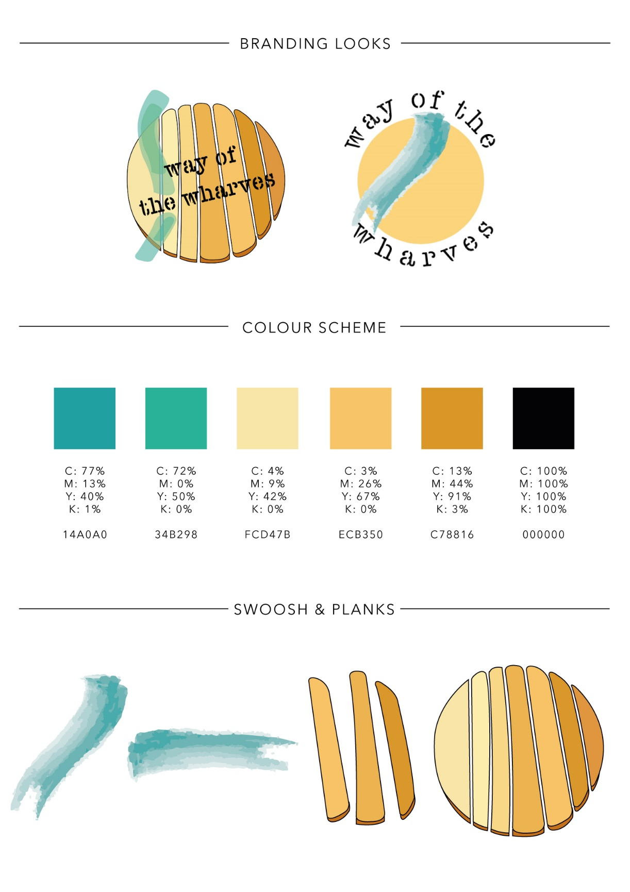
Here are some of the logo choices, colour ranges, drawings and branding looks available to download at www.thewharves.org

WEIRD WHARVES
BRANDING, LOGOS & PEN-DRAWINGS (CONT.)

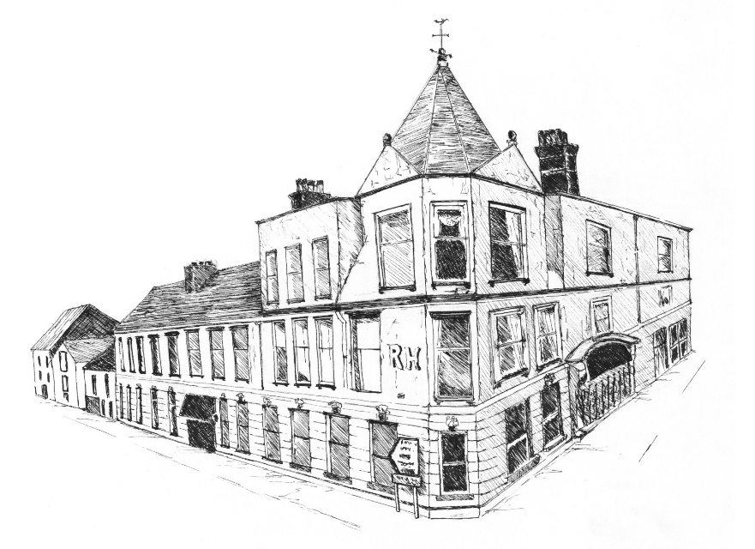
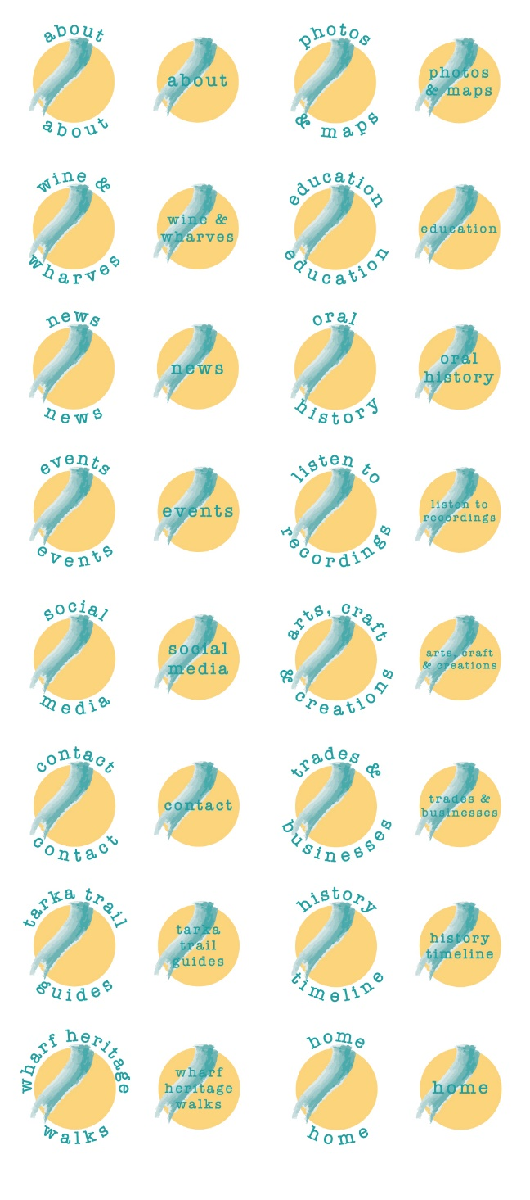
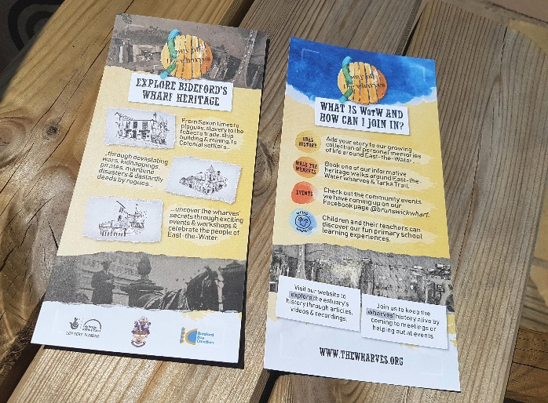
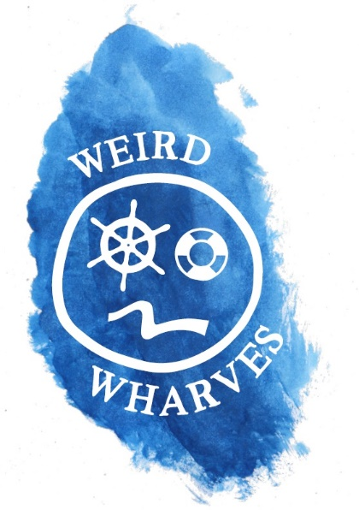
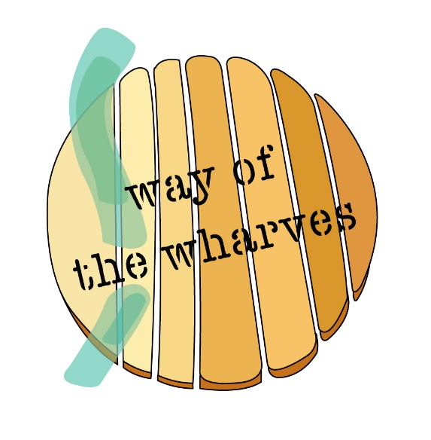
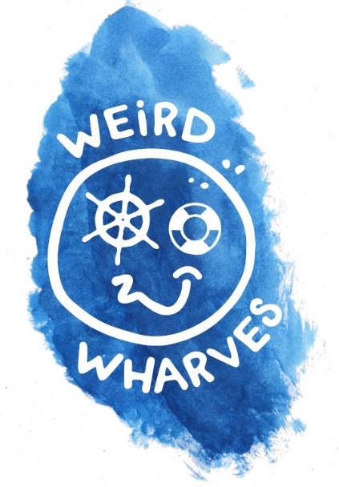
WEIRD WHARVES
OLD MAPS, PHOTOS & AERIAL IMAGES
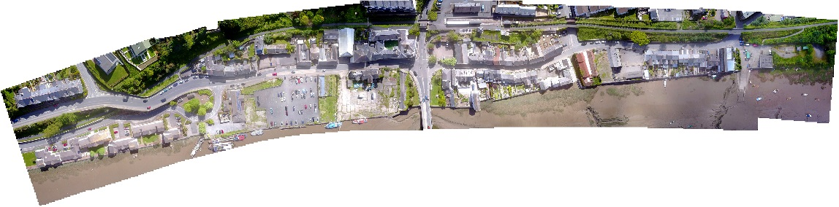
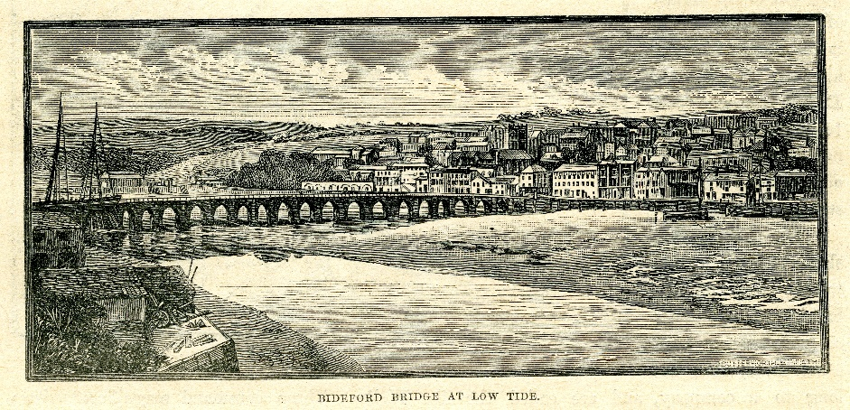
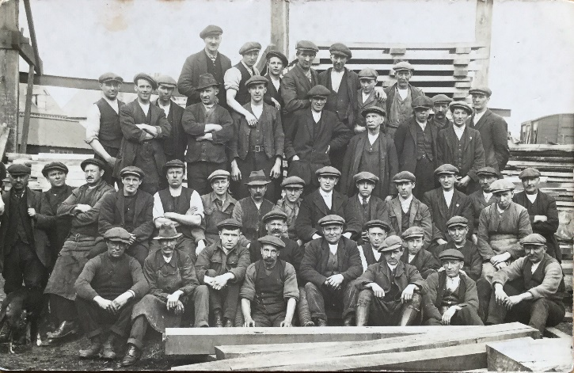
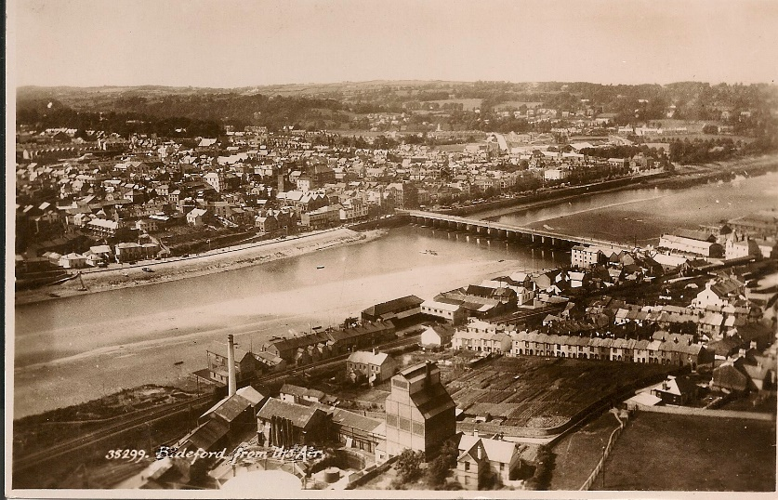
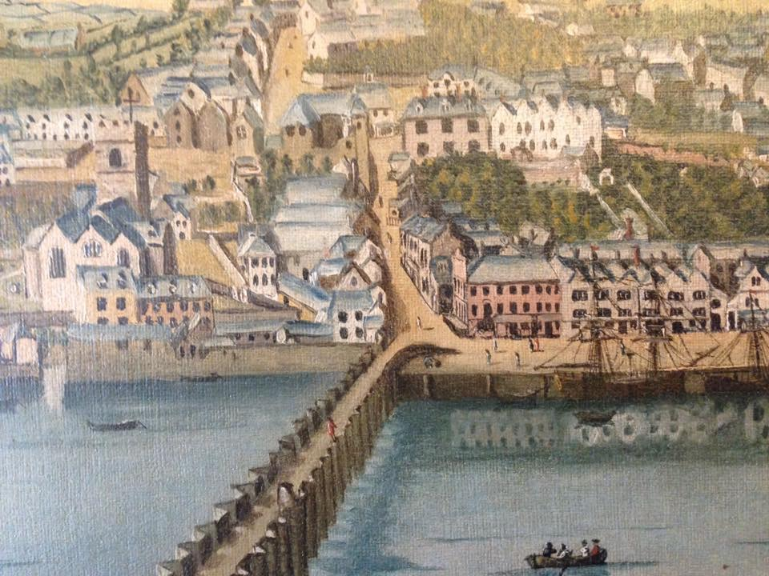
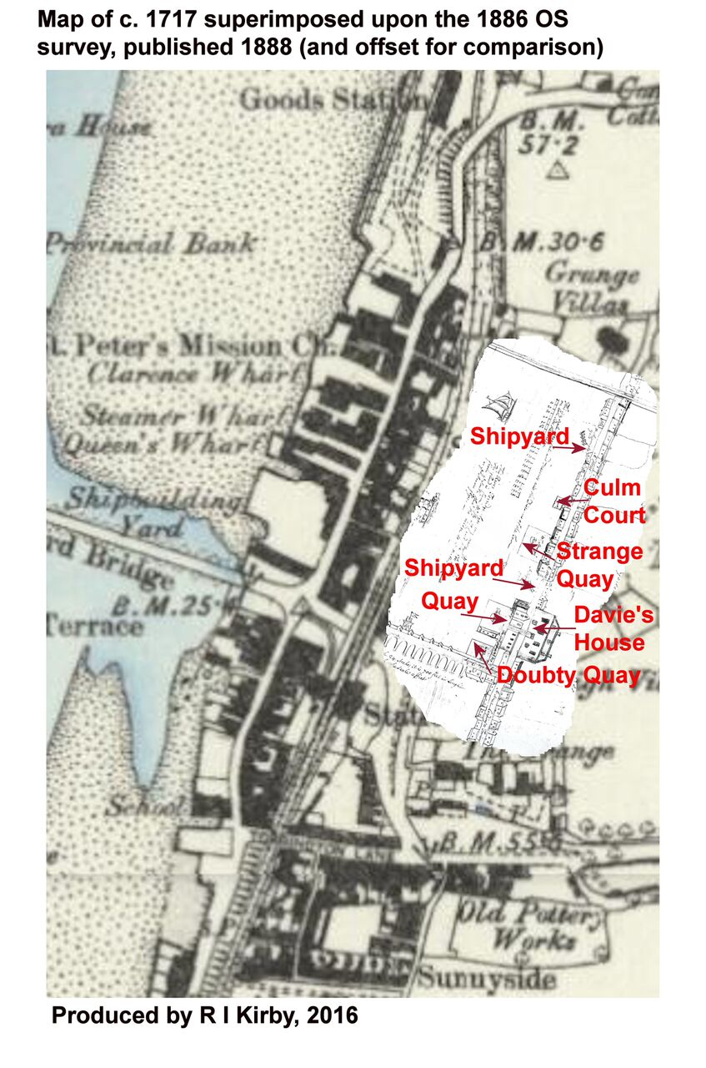
LESSON PLAN: Way of the Wharves East the Water Primary School
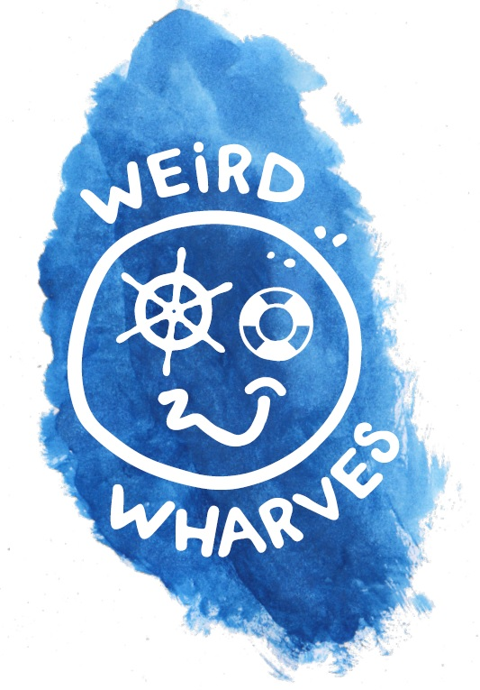
LESSON TITLE: Sculpting the Wharves :Taz Pollard
PoS/NC Link:
Date: June 12th and 26th | Duration: 1 hour
Learning Objectives:
- To know where clay comes from and its links to rivers and estuaries
- To make a pinch pot fish or bird
- To refine their animals with mark making techniques

Lesson content |  | Your role/role of other adults
- Discuss: what clay is and where it comes from. Links to rivers and estuaries  - Demonstrate: pinch pot technique.  - Practical: Pupils to make pinch pots  - Demonstrate: constructing an animal from 2 pinch pots, mark making  - Practical: Pupils to construct their weird wharves animals |  | Facilitator, demonstrator/assist with clay moulding, using shaping tools.
Assessment
- Fine motor skills, pinching, squeezing, pressing and mark making

Resources checklist
- Clay, slip, mark making tools
- Boxes for each class clearly labelled

LESSON PLAN: Way of the Wharves: East the Water Primary School
LESSON TITLE: ‘Tis a Strange World’ (Part the 1st)
PoS/NC Link: History; literacy
Date: June 12th | Duration: 1 hour
Learning Objectives:
- To understand that Bideford was an important trade centre
- To learn about a local character from the past
- To enhance listening skills by listening to a story
- To interpret the story through freeze-frame drama
Lesson content |  | Your role/role of other adults
- Introduction to Bideford, 17th century trade and John Strange  - Listen to a story about John Strange based on his portrait in Bideford Town Hall  - Interpret John’s story through freeze-frame drama |  | Storyteller and drama facilitator; other adults to assist with freeze-frames.
Assessment
- Listening skills, group working and recall

Resources checklist
N/A

LESSON PLAN: Way of the Wharves: East the Water Primary School
LESSON TITLE: ‘Tis a Strange World’ (Part the 2nd)
PoS/NC Link: history; literacy
Date: June 18th | Duration: 1 hour
Learning Objectives:
- To understand that Bideford was an important trade centre
- To understand that people departed from the wharves on long and dangerous voyages to earn a living
- To experience, through first person storytelling, what life was like for the sailors who crewed John Strange’s ships
- To enhance listening skills by listening to a story
- To interpret the story through freeze-frame drama

Lesson content |  | Your role/role of other adults
- Introduction to the 17th century world map and trade links to Bideford  - Listen to a story about the life of a sailor from Bideford  - Interpret the story through freeze-frame drama |  | Storyteller and drama facilitator; other adults to assist with freeze-frames.
Assessment
- Listening skills, group working and recall

Resources checklist
N/A

LESSON PLAN: Way of the Wharves East the Water Primary School
LESSON TITLE: Critter Detectives

PoS/NC Link:
Date: 27/6/18 | Duration: 1 hour / class
Learning Objectives:
Find out about microscopic organisms in the water.
Learn the importance of microscopic life on Earth.

Lesson content |  | Your role/role of other adults
Hunt for and observe microscopic organisms using magnifiers and microscopes. Comment on physical features.  Identify adaptations in these animals which enable it to survive. Comment/suggest functions of features.  Microbes are not all “germs”. Make a superhero microbe activity – adapt your microbes to have a “good” super-power. |  | Support, hands-on  Use of digital microscope
Assessment
Adaptations seen in pupils “good” microbe, pupil explains adaptation.

Resources checklist
Need a white board please.

LESSON PLAN: Way of the Wharves East the Water Primary School
LESSON TITLE: Slime Kilns

PoS/NC Link:
Date: 28/6/18 | Duration: 1 hour / class
Learning Objectives:
Know what a Lime Kiln is and what happens in one.
Give examples of what happens in a chemical reaction.
Be able to carry out an experiment.

Lesson content |  | Your role/role of other adults
Tutorial on Lime Kilns, followed by what is chemistry/chemical reactions.  Watch demo by facilitator on how to make slime.  Pupils make own slime to take home. |  | Support, hands-on
Assessment
Follow instructions to make slime.
Recall what happens in a Kiln and what one may see in a chemical reaction.

Resources checklist
Need a white board please.

LESSON PLAN: Way of the Wharves East the Water Primary School
LESSON TITLE: Salt Cod Fishing Storytelling and Talk and Tasting
PoS/NC Link:
Date: July 3rd | Duration: All afternoon
Learning Objectives:
- Understanding the history of fishing across the Atlantic from Bideford Wharves-through storytelling and Map making
- Demonstrating salt Cod recipes and Talk on fishing in Newfoundland
- Tasting 2 international salt Cod dishes and receiving recipes for a range of salt cod dished

Lesson content |  | Your role/role of other adults
1st Activity  - Storytelling to explain the Journey of Fishermen from Bideford to Newfoundland to catch, preserve and trade Cod caught from the waters off Newfoundland.  - Map making of the Atlantic Ocean and illustration to be retained in the classrooms. Basic understanding of how important the Wharves east he water were to this activity for many centuries. Creative /artwork.  2nd Activity  - Salt Cod Talk and Tasting. Show dried split Cod as traded and eaten in many countries. Learning about international recipes and ingredients  - Tasting 2 recipes a salt cod and garlic pate on Ritz biscuits and Jamaican fish balls served with tomatoes sauce to dips. Recipes will be made available for children to take home. Learning about International recipes and ingredients and tasting the fish dishes, short Talk on life in Newfoundland and boats used to catch the Cod. Listening and Q&A session.  Change over for 2nd session after the first hour -therefore All 120 will do both sessions |  | Teacher and classroom assistants  Children organised to do both tasks by Mike Teare and Anthony.  Teacher and 2Cllassroom assistants  Felicity Sylvester –Talk and 2 helpers Sue L and Fiona G in kitchen preparing the dishes of food to taste.  Clearing and washing up. Restoring kitchen
Assessment
- Attention to Story and Q&A sessions, Enthusiasm and creative interest in the Map making and understanding the role of Bideford East role in establishing the Cod fisheries in newfoundland.
- Attention to Talk with Q and A session as required -involvement and enthusiasm. Interest in the photos on the tables. Interest in the International recipes and tasting the 2 recipes. Vegetarian children can absorb the information and take part in the Q&A session

Resources checklist
- Storytelling props, Material for maps and artwork-map to be retained in the classrooms.
- Salt Cod and ingredients for made up recipes to taste, Photos and info. about Newfoundland

LESSON PLAN: Way of the Wharves East the Water Primary School
LESSON TITLE: SS Freshspring
- PoS/NC Link: History - To understand the methods of historical enquiry
To understand how our knowledge of the past is constructed from a
range of sources
Date: July 10th | Duration: 55 minutes – 1 1/2 hours (adapted accordingly)
Learning Objectives:
- To find out about the SS Freshspring in preparation for an on-board visit

Lesson content |  | Your role/role of other adults
Whole Class Activity  - Look at artefacts, use as clues as to what they are going to be learning about – History Detectives  - Match timeline and key fact labels to artefacts and put in order  Group Activities:  - Look at photographs and other archival material  - Track journey to Malta – use map  - Artefact activity – (to including some items of clothing)  - Knot tying  Class Plenary:  Recap key facts and set scene for tomorrow’s visit to the ship |  | Lead session  Ideally an adult per group to help guide children and lead discussion where necessary
Assessment
- Plenary – capturing information learnt and summarising different types of sources

Resources checklist
- Artefacts/objects for whole class session (including glass bottle, coal, oil, bottle of water, replica ship’s bell, lamp)
- Timeline and fact labels
- Photographs – both on USB and laminated copies
- Map
- Archival documents – laminated photos, copies of ship’s drawings/plans, ship’s registration certificate, sections from book/interview
- Knot tying board
- If possible laptop & access to projector/white board to show photos to whole class

LESSON PLAN: Way of the Wharves East the Water Primary School
LESSON TITLE: SS Freshspring tour
PoS/NC Link: Local History Study
Design & Technology - understanding of strengthening
Science – uses of materials
Date: July 11th | Duration: 50 minutes
Learning Objectives:
- To find out about the SS Freshspring
- To make their own rope (hawser)

Lesson content |  | Your role/role of other adults
Whole Class Welcome and quick Health and Safety Briefing (5 mins)  Split class into two groups  Group 1 – Tour of the ship (20 mins)  Group 2 – Rope-making activity  Swap activities:  Group 1 – Rope-making activity (20 mins)  Group 2 – Tour of the ship (20 mins)  Gather two groups back together (5 mins) |  | Lead  Our volunteer will lead the tour and I will lead the rope-making session  Two adults per group to help guide children and remind them of Health and Safety issues where necessary
Assessment
- Discussion both during and post visit

Resources checklist
- Rope-making equipment: Jack, Traveller, Top, Yarn

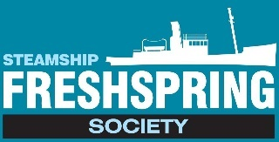
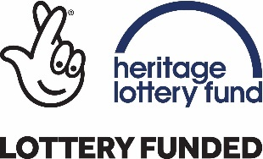

Risk Assessment for Visiting Schools/Youth Groups
Risk Assessment of: SS Freshspring |  |  |  | Assessor(s): Hayley Buscombe | Date: 27th June 2018
Overview of activity / location / equipment / conditions being assessed: |  | School/group visits will involve movement throughout the ship on a variety of levels.
Generic or specific assessment?  Generic |  |  | Context of assessment Site visit
Hazard(s) identified | Persons affected |  | Existing controls |  |  | Additional controls required
The ship is moored alongside the quay near the car park. There will be the usual vehicular movement within the car park. | School children, young people and accompanying adults |  | School staff are responsible for supervising their group of children/young people  Schools recommended to do their own risk assessment
As the ship is berthed alongside the quay there is the potential for falling overboard | School children, young people and accompanying adults |  | School to provide appropriate ratio of adults and move around the ship in small groups each led by an adult  Adults to supervise children at all times particularly near the sides of the ship  Children and youth groups reminded not to run on deck.  Particular areas of concern are highlighted to supervising school staff/group leaders at pre-visits and/or the start of the session  Life buoys on board |  |  | Monitoring of what happens when open to school groups
The ship takes the visitor onto a variety of levels using fairly steep ladders. | School children, young people and accompanying adults |  | All steps have handrails.  All visitors will be reminded that they should face the steps and hold onto the handrails when descending or ascending them.  Particular areas of concern are highlighted to supervising school staff/group leaders at pre-visits and/or the start of the session. |  |  | Monitoring of what happens when open to school groups
There are several combings throughout the ship which are potential trip hazards. | School children, young people and accompanying adults |  | The school/youth groups will be reminded to take care when moving around the ship, particularly watching out for combings  Particular areas of concern are highlighted to supervising school staff/group leaders at pre-visits and/or the start of the session. |  |  | Monitoring of what happens when open to school groups
The ship has numerous fixed floor obstacles which are a potential trip hazard. | School children, young people and accompanying adults |  | The school groups/visitors will be reminded to take care when moving about on deck, particularly watching out for fixed obstacles on the floor.  School groups/visitors will be directed away from potential trip hazards where possible by stewards and group leaders. |  |  | Monitoring of what happens when open to school groups
Bumps, scrapes and head hazards.  Several areas of the ship have low door entrances, ceilings and/or structural hazards. | School children, young people and accompanying adults |  | All visitors will be reminded to take care when moving about the ship particularly looking out for low door entrances and things that they may bump their head on.  When descending/ascending stairs visitors will be reminded to watch their backs by stewards and group leaders.  Particular areas of concern are highlighted to supervising school staff/group leaders at pre-visits and/or the start of the session. |  |  | Monitoring of what happens when open to school groups
Fire | Visitors |  | A full fire risk assessment has taken place  All stewards understand how to evacuate the building  Groups will be notified of emergency procedures and fire exits.
Disorientation on site | School children |  | School staff are responsible for supervising their group of children/young people. School advised to divide into smaller groups with adults supervising them to move around the site.  School to provide appropriate ratio of adults. |  |  | Monitoring of what happens when open to school groups
 | Children with SEND and support staff |  | School staff are asked to contact the Educational and Project Officer to discuss requirements for children with specific needs particularly access requirements.

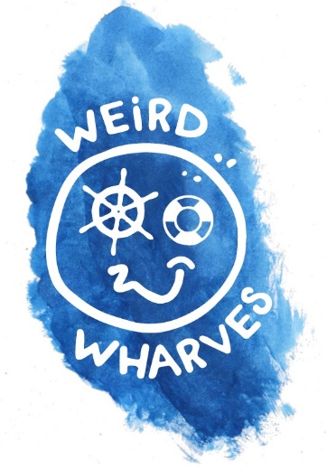
CONTACT DETAILS

Way of the Wharves
Email: project@bbcdevon.org
Facebook: @Brunswickwharf
www.thewharves.org
Tel. 07870 631358

