LESSON PLAN: Way of the Wharves East the Water Primary School
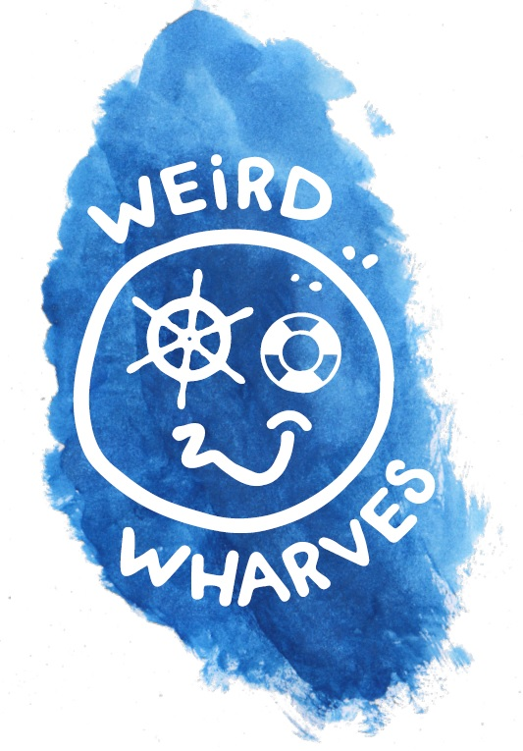
LESSON TITLE: Critter Detectives

PoS/NC Link:
Date: 27/6/18 | Duration: 1 hour / class
Learning Objectives:
Find out about microscopic organisms in the water.
Learn the importance of microscopic life on Earth.

Lesson content |  | Your role/role of other adults
Hunt for and observe microscopic organisms using magnifiers and microscopes. Comment on physical features.  Identify adaptations in these animals which enable it to survive. Comment/suggest functions of features.  Microbes are not all “germs”. Make a superhero microbe activity – adapt your microbes to have a “good” super-power. |  | Support, hands-on  Use of digital microscope
Assessment
Adaptations seen in pupils “good” microbe, pupil explains adaptation.

Resources checklist
Need a white board please.

